Historical Heads

Objectives - Students will :
- demonstrate an understanding of the life experiences of an enslaved African through the use of a Historical Head format.

learning standards – See chart

Materials
- Historical Head Sheet
- Run-away Slave Notices
- Crayons or colored pencils
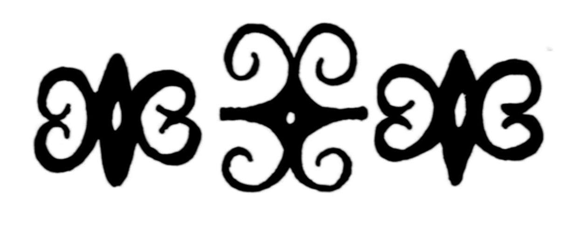

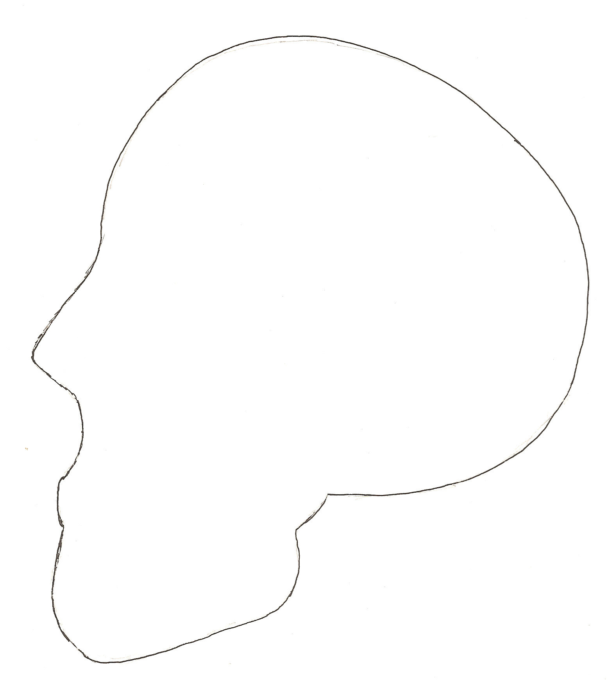
teaching sequence
- Class discussion
- Students are asked think about the thoughts, dreams, visions, ideas and motivations local African American slaves might have had.
- The teacher will hand out Historic Head sheets and Run-away Slave Notices from Lesson One.

2. Analyze a document (Run-away Notices)
a. Students will choose one enslaved African to focus their “Head” on.
b. Students are to draw at least four illustrations representing the images of the thoughts, dreams, visions, ideas and motivations local African American slaves might have had, inside the head. Each image must be numbered. Students are to use a separate sheet of paper to explain their numbered illustrations.

- Class discussion
a. After they have completed their Historical Head they will share their work
with the class.

