JUDY JACKSON
Col. # | Transcription
1 | The Name of every Person whose usual place of abode on the first day of June, 1850, was in the family
2 | Age
3 | Sex
4 | Color
5 | Profession, Occupation, or Trade  of each Male Person over 15 years  of age
6 | Value of real estate owned
7 | Place of Birth, Naming the State, Territory, or Country
8 | Married within the year
9 | Attended School within the year
10 | Persons over 20 y'rs of age who cannot  read & write
11 | Whether deaf and dumb, blind, insane, idiotic, pauper, or convict
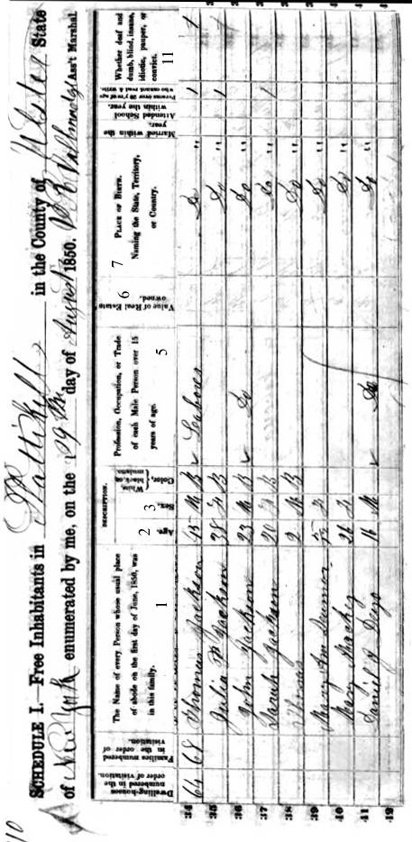
Questions for 1850 Census

- According to this census, when was Judy (Julia) Jackson born? ___________

- How many people were living in her household? _________

- What was Judy’s husband’s name? _________________

- What was Judy’s husband’s occupation? _____________

- What do you think that means? _________________

- Could Judy or her husband read or write? ___________

- What town was Judy living in? ____________________

