JUDY JACKSON
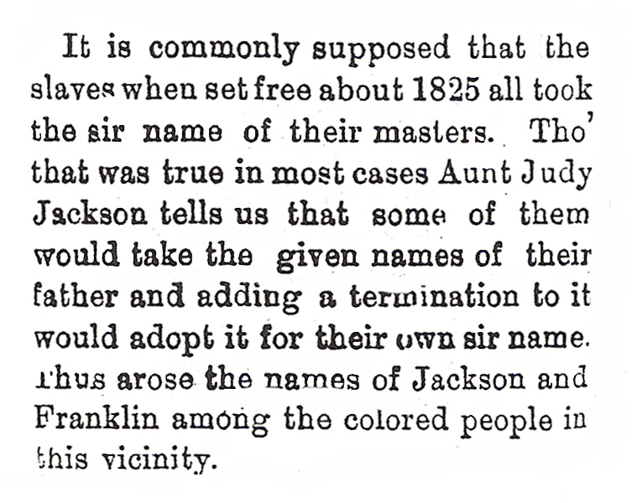
The New Paltz Independent - April 10, 1896

1. According to “Aunt Judy”, how did some freed slaves get their last names?
_________________________________________________________________________________________________________________________________________________________________________________________________________________________________________________________________________________________________________________
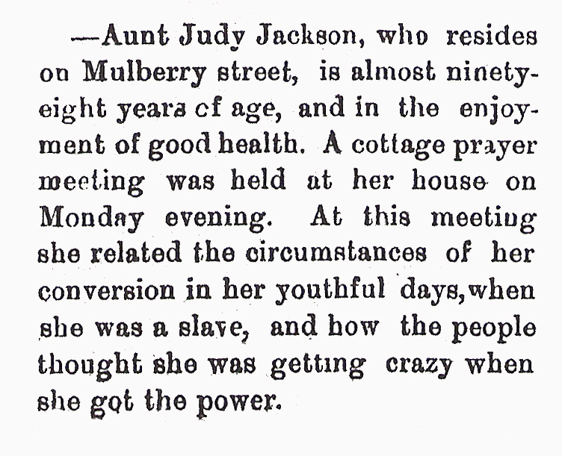

The New Paltz Independent – January 18, 1989

2. At almost 98, Aunt Judy still had prayer meetings at her house. What kinds of stories did Aunt Judy tell at the meeting on January 18th?
____________________________________________________________________________________________________________________________________________________________________________________________________________________________________________________

