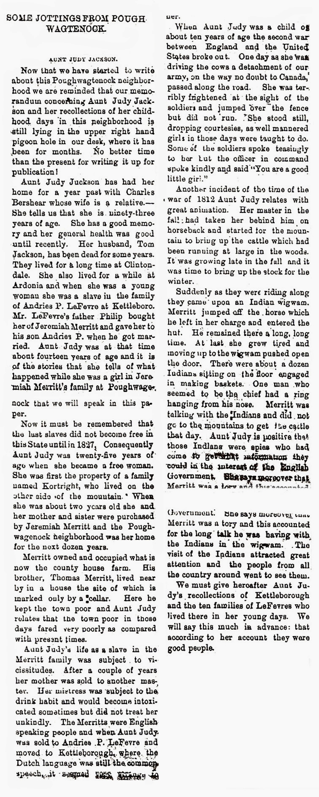
SOME JOTTINGS FROM POUGHWAGTENOCK
-taken from the New Paltz Independent , May 18, 1894

