OBITUARY FOR JUDY JACKSON
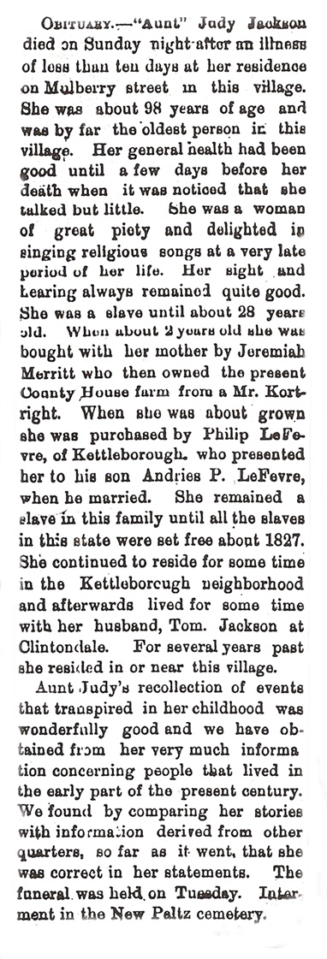

- According to her obituary, when was Judy Jackson born ?
___________________________________________

- What happened to Judy when she was 2 years old? ______________________________________________________________________________________
___________________________________________

- When was Judy freed? ______________________

- How would you describe Judy? ________________________________________________________________________________________________________________________________________________________________________________________________________________________________________________________________________________________________________________________________________________________________________
From The New Paltz Independent – April 28, 1898

