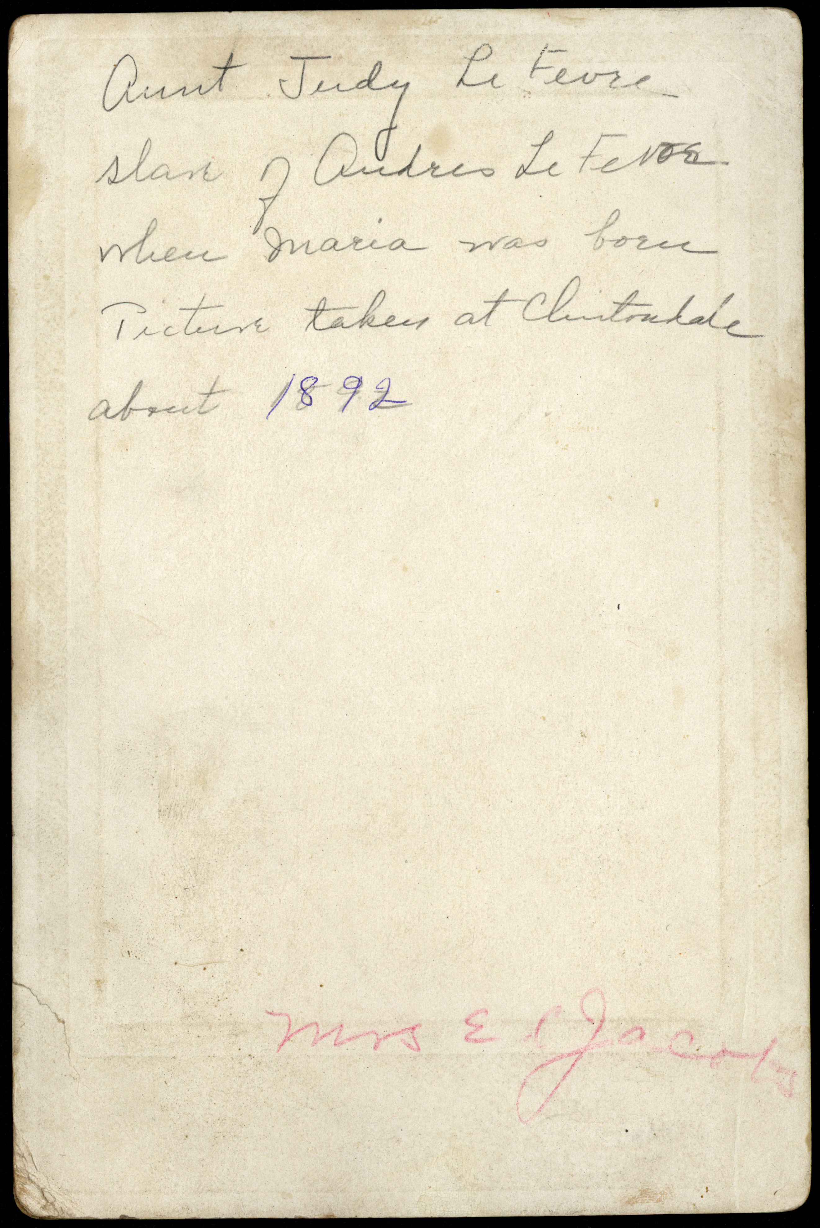
AUNT JUDY JACKSON
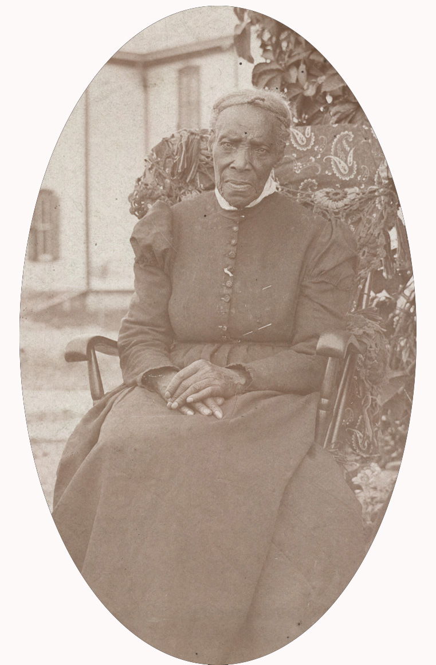
Back of photo
Aunt Judy Lefevre
slave of Andries Lefevre
when Maria was born
Picture taken at Clintondale
about 1892.
Judy (Julia) Jackson.
Clintondale, Ulster County
1892

