JUDY JACKSON

Objectives - Students will :
- analyze and interpret information from mid-19th century newspapers;
- draw inferences about the life of Julia Jackson, an enslaved Ulster County woman;
- work in cooperative groups to evaluate and choose sources to create a “Judy’s Wheel”.

learning standards – See chart

Materials
- Picture of Judy Jackson
- Some Jottings from Poughwagtenook sheet
- 1850 NYS Census
- Two newspaper clippings
- Judy’s Obit
- Judy’s Wheel Template (can be enlarged to 11” X 18”)
- Crayons and or colored pencils
- Activity Sheet

Background information
Born just a few years after the Gradual Manumission Law was passed in 1799, Julia Jackson, endearingly called Aunt Judy, spent the first 25 years of her life being bought and sold by local Ulster County landowners. She was separated from her mother by the time she was two or three and then sold and given as a “wedding gift” by the time she was eleven. The exact date of her freedom is unknown, but according to the Gradual Manumission Act, she would have been freed by the age of 25. Judy and her husband Thomas appear on most censuses taken between 1845 and 1880, but her date of birth varies between 1809 and 1812. Her obituary lists her age in 1898 as 98. Every census listing Judy and her husband states that neither could read nor write.

The earliest census that Julia Jackson appears on is the 1845 New York State Census. This census has in depth agricultural information and lists the following details concerning the Jackson homestead:

- Four people of color are living in this household
- One member is a male under 45
- One child is between the age of 5 and 16
- 22 ½ yards of flannel and other woolen cloth was manufactured by this household
- ½ acre of unimproved land was owned by this household
- 25 pounds of potatoes were grown on ½ acre of land
- Two meat cows were owned, one cow was milked
- 100 lbs. butter was produced
- Five hogs were owned

Being land owners, the Jackson family fared much better than many other people of color at his time.
Aunt Judy was well known for her excellent memory, retelling stories from her early childhood. Her stories were often found in the local papers and in Ralph Lefevre’s, History of New Paltz, New York and the Old Families from 1678 to 1820. The 1898 obituary for “Aunt Judy” lists her place of internment as New Paltz Rural Cemetery, but no documentation or headstone has been found to locate her plot.



teaching sequence
- Class Discussion
  - Give students a brief description of Judy Jackson. Explain that this activity will take three or four class periods. Each document will give them more information, enabling them to piece together Judy Jackson’s (an emancipated slave) life.
  - Break up class into groups of four. Assign cooperative roles.
  - Distribute packets and review the types of documents they will encounter in each packet (newspaper clippings, an obituary, a photograph, and the 1850 Federal Census). You may need to review what an obituary is.
  - Explain that this activity will culminate in the creation of Judy’s Wheel.
- Interpreting information from a document
  - Students will examine each document and answer the accompanying questions.
  - Review the answers to the questions before continuing on to the culminating activity.
- Create a Judy Wheel*
  - Distribute the Wheel templates to each group. The wheel has six outer sections and one circle in the middle.
  - Instruct the students to complete the Wheel as follows:
- Inner circle: Image of Judy Jackson with her name
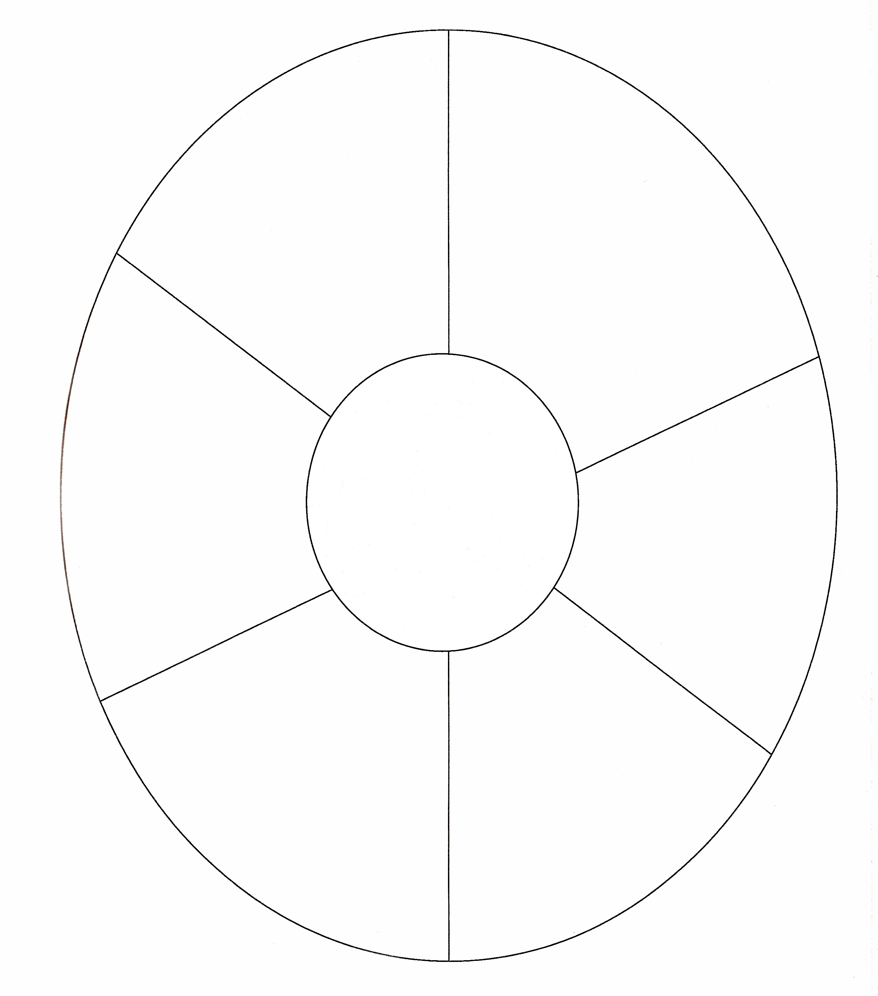
- Outer sections:
      - Approximate date she was born (can use c. 1800) and when she died.
      - One fact about her childhood
      - Another detail about her childhood
      - Family life
      - Something you found interesting about Judy’s life or personality?
      - How does the information surrounding Judy Jackson’s life help you understand the system of slavery in New York?
  - Have students create a rough draft of their Wheel before transferring it onto large paper. Encourage students to illustrate the sections of the outer wheel as well as the inner wheel.
  - Each group shares their Wheel with the class.

*- idea adapted from Tara Lindquist’s, Seeing the Whole Through Social Studies.

