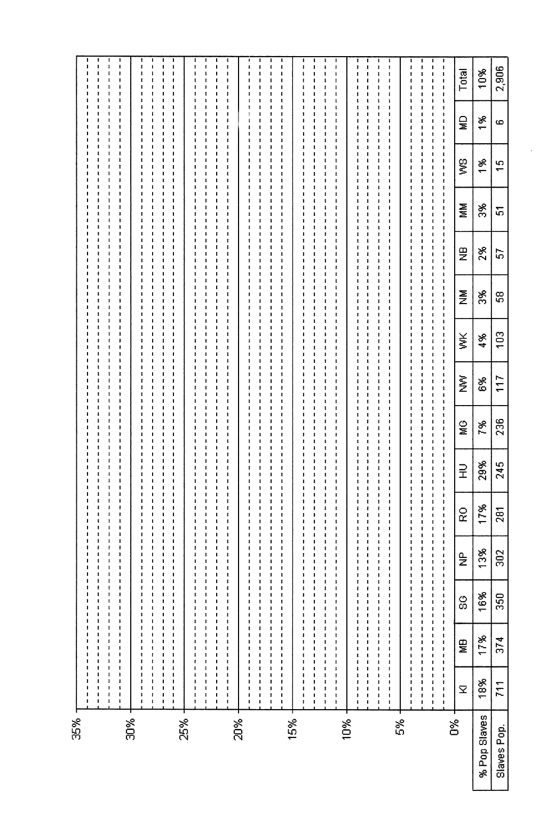
1790 Federal Census Population of Ulster County

