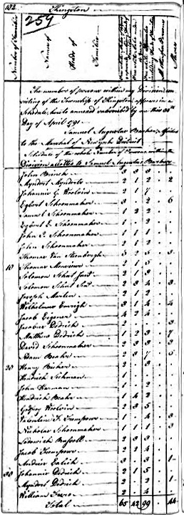
EXCERPT FROM THE
1790 KINGSTON CENSUS

