COL. GAASBEEK LETTER
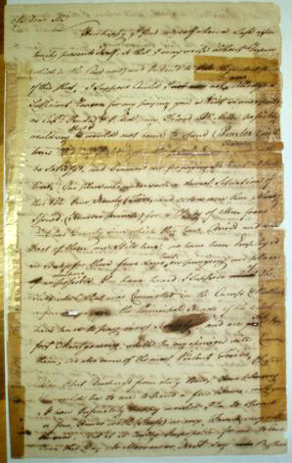
Peter Van Gaasbeek to Jacob Marius Groen
May 30, 1776

My Dear Sir
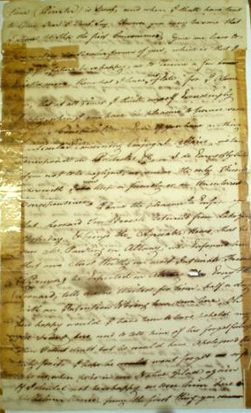
How happy I find myself when a safe opportunity presents itself, so that I may write without reserve (which is the case now) and to forward to you the (illegible) of this plase - I suppose could I not Alledge a sufficient Reason for my paying you a visit so unexpected as Capt. Fonda & I did my friend Mr. Miller would possibly say, that I would not come to spend (Pinxter) with him, But my (damaged text) you will be satisfyed, and commend me for paying the visit at this time - Our place was under such a dismal situation of this Vile, Crue Namely Tories, and orders were then already Issued (However private) for a Body of Men from Dutchess County since which they have arrived and (torn text) part of them are still here, we have been emply'd stady for these five days past in purging our place as much as possible, You have heard I suppose of the Salt mob that was committed in the Camp & (damaged text) a few days ago, the Principle heads of the Mob have had to pay most severely, and are sent to fort Montgomery, which in my opinion will Co_____ them, as also some of the most Violent Tories
Oh Sir, Were I but Discharg'd from duty now, How pleasing it would be to me to spend a few hours with you & how Infinetly happy would I be to spend a few Hours with Steefs as my friend very welt know, But it is really impossible for me to leave this day, to Morrow or Next day, By that time Pinxter is spent, and when I shall have time to come over I cannot say, However you may be sure that I shant let slip the first convenience, give me leave to Request one particular favour of you, which is that I may for the future be so happy as to receive a few Epistles more than what I have done of late, for I assure you that at all times I think myself exceedingly happy when I can have the pleasure to peruse some of your compositions, Even if you have nothing particular to or Concerning Conjugal affairs, we can correspond on Politicks &c. - I do Earnestly Intreat you not to be negligent as you are the only friend wherewith I now keep a friendly or uninterrupted Correspondence
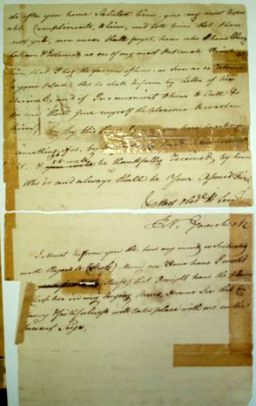
I have the pleasure to inform you that Leonard Ten Broeck returned from Lake George yesterday & brings the Agreeable News that he saw Mr. Pawling in Albany, who Informed him that our Most Worthy our Most Intimate Friend (Bruyn) he expected in Albany (torn text) Even'g Mr. Leonard tells me he waited for him half a day with an Intention to bring him down here, Oh how happy would I have been to have beheld my old friend here, and to tell him of his forgetfulness when I don’t doubt he would have Apologised properly for it, I hope he wont forget or forsake us when he is in our Native Place again, If I should not be so happy as to see him here on his return Home, pray the first thing you do after you have saluted him, give my most Respectable Compliments to him, and tell him that I have not yet, nor ever shall forget him who have Always taken & Esteemed as one of my most Intimate Friends - tell him that I beg the favour of him as soon as he returns to your place, that he shall inform by letter of his arrival and if Inconvenient to him to call & see me, shall give myself the pleasure to wait on him
By this time I pray you have heard something, if so by __________ safe hand communicate it & it will be thankfully received by him
Who is and always shall be Your Assured Friend
& Most Obed't Serv't
Col. Gaasbeek
I must inform you tho how my mind is situated with Regard to Steefs - Many an hour have I wished (damaged text) Steefs that I might have the pleasure (damaged text) Clasp her in my longing arms, It seems Sir that Constancy & Faithfulness will take place with me in the present Siege (transcriber by Lisa Bruck )

