BOUNTY HUNTERS ON HUGUENOT STREET

Objectives - Students will :
- analyze and interpret information from early 19th century documents;
- illustrate the similarities and difference in in two documents;
- draw conclusions about attitudes towards enslaved Africans during the early 19th century in Ulster County.

learning standards – See chart

Materials
- Magnifying glasses if available
- Document 1 - The Society of Negroes Unsettled document and transcription
- Document 2 - document and transcription
- Activity Sheet

Background information

Document 1- The Society of Negroes Unsettled - The problem of runaway slaves became so great that in 1810 a group of New Paltz slave holders joined together to form “The Society of Negroes Unsettled”. This group of twelve men appointed four among them to “go in Search of the Said Run aways”. They were to be paid $14 a day for travel within sixty miles from home and $16 a day for travel further than sixty miles from home. It was also agreed that every slave owner would reward the captor a sum of thirty dollars when the slave was delivered to his or her master or brought to the Ulster County jail. Each subscriber was also asked for an advance of $5.00 to be paid to the bounty hunters about to embark on the search.

Document 2 – Articles of Agreement - Jacob J. Hasbrouck and Isaiah Hasbrouck agreed to Josiah Eltinge, William Hasbrouck, Philip Dayo,and Andries Lefever Jun^{r} that if they found any of the runaway slaves listed “they may Sell and Dispose of the Said negroes” . They were to be paid a percentage of the amount the slave was sold for, returning the remainder to the owner of the said slave. They also agreed that if they did not find any of the runaways, they would “make no Charge for their trouble, time, nor Expence they may Sustain”.

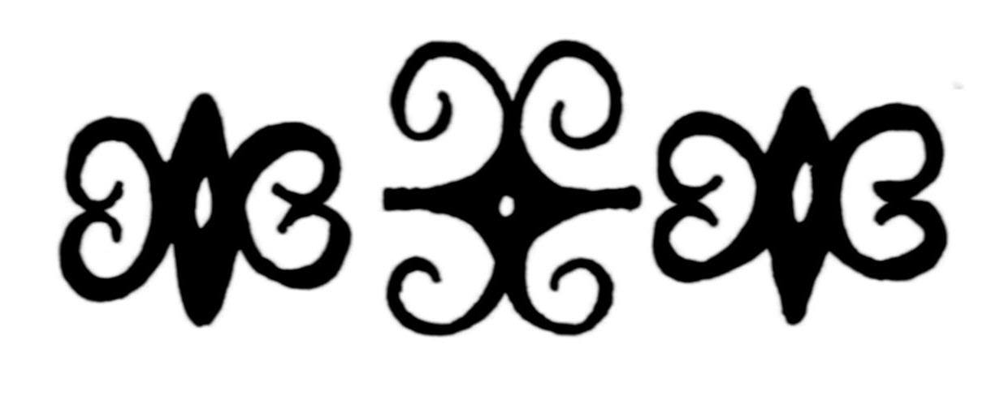

teaching sequence
- Class Discussion
  - Explain what is meant by the term “bounty hunter”. Distribute a copy of the Document 1, The Society of Negroes Unsettled document and transcription, and the transcription to the students. Have them read along with you.
  - Discuss any unfamiliar terms.
  - Distribute a copy of Document 2, Articles of Agreement document and transcription and the transcription to the students. Have them read along with you.
  - Discuss any unfamiliar terms.
  - Distribute Activity Sheet
- Interpreting information from a document
  - Students work in pairs or small groups to answer questions on the activity sheet.
  - Allow 20-30 minutes for students to work on Sheet.
- Class Discussion
  - Call on representatives from each group or pair to answer questions.
  - You may choose to save Question 6 - What new information does this document give you about the institution of slavery in Ulster County?
for students to review and complete for homework.

