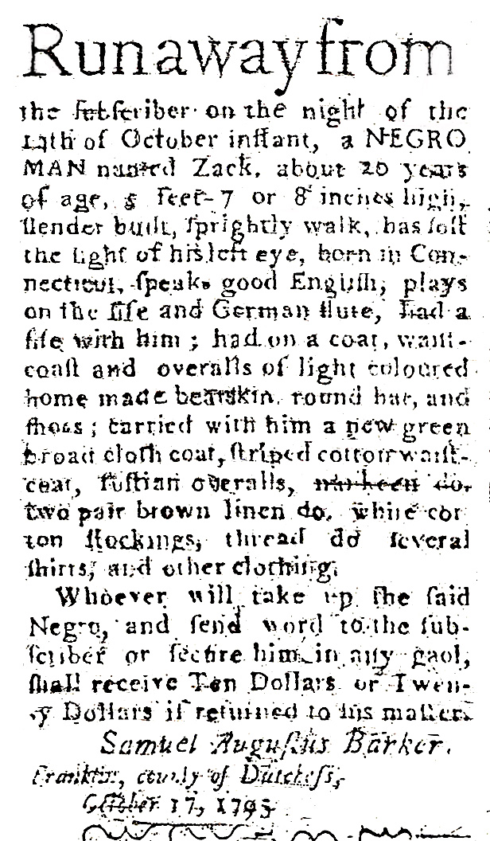
ZACK OF DUTCHESS

Runaway from
the subscriber on the night of the
14th of October instant, a NEGRO
MAN named Zack, about [20] years
of age, 5 feet 7 or 8 inches high,
slender built, sprightly walk, has lost
the sight of his left eye, born in Con-
neticut, speaks good English, plays
on the fife and German flute, had a
fife with him; had on a coat, waist-
coat and overalls of light coloured
home made bearskin round hat, and
shoes; carried with him a new green
broad cloth coat, striped cotton waist-
coat, fustian overalls, nankeen do [ditto].
two pair brown linen do. white cot-
ton stockings, thread do. several
shirts and other clothing.
Whoever will take up the said
Negro, and send word to the sub-
scriber or secure him in any goal,
shall receive Ten Dollars or Twen-
ty Dollars if returned to his master. Samuel Augustus Barker
Franklin, county of Dutchess
October 17, 1795

