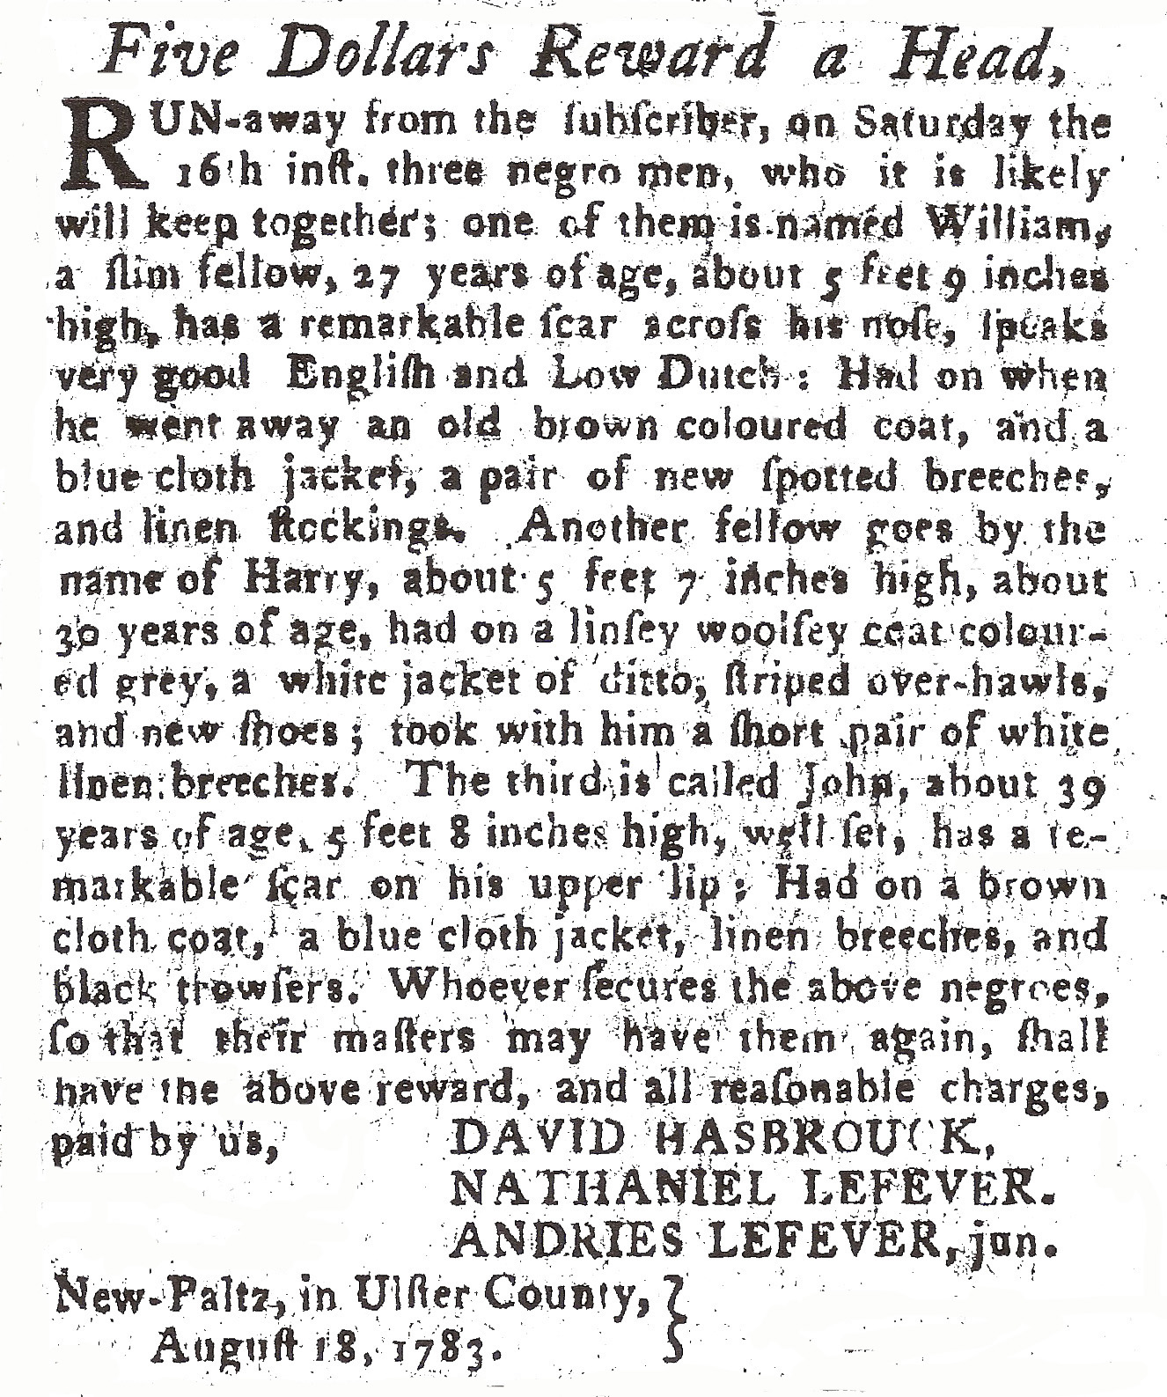
WILLIAM, HARRY AND JOHN OF NEW PALTZ
Five Dollars Reward a Head,
RUN-away from the subscriber, on Saturday the
16th inst. three negro men, who is likely
will keep together; one of them is named William,
a slim fellow, 27 years of age, about 5 feet 9 inches
high, has a remarkable scar across his nose, speaks
very good English and Low Dutch: Had on when
he went away an old brown coloured coat, and a
blue cloth jacket, a pair of new spotted breeches,
and linen stockings. Another fellow goes by the
name of Harry, about 5 feet 7 inches high, about
30 years of age, had on a linsey Woolsey coat colour-
ed grey, a white jacket of ditto, striped over-hawls,
and new shoes; took with him a pair of white
linen breeches. The third is called John, about 39
years of age, 5 feet 8 inches high, well set, has a re-
markable scar on his upper lip; Had on a brown
cloth coat, a blue cloth jacket, linen breeches, and
black trowsers. Whoever secures the above negroes,
so that their masters may have them again, shall
have the above reward, and all reasonable charges,
paid by us, DAVID HASBROUCK NATHANIEL HASBROUCK ANDRIES LEFEVER, JUN.
New-Paltz, in Ulster County,
August 18, 1783.

