SAM OF POUGHKEEPSIE
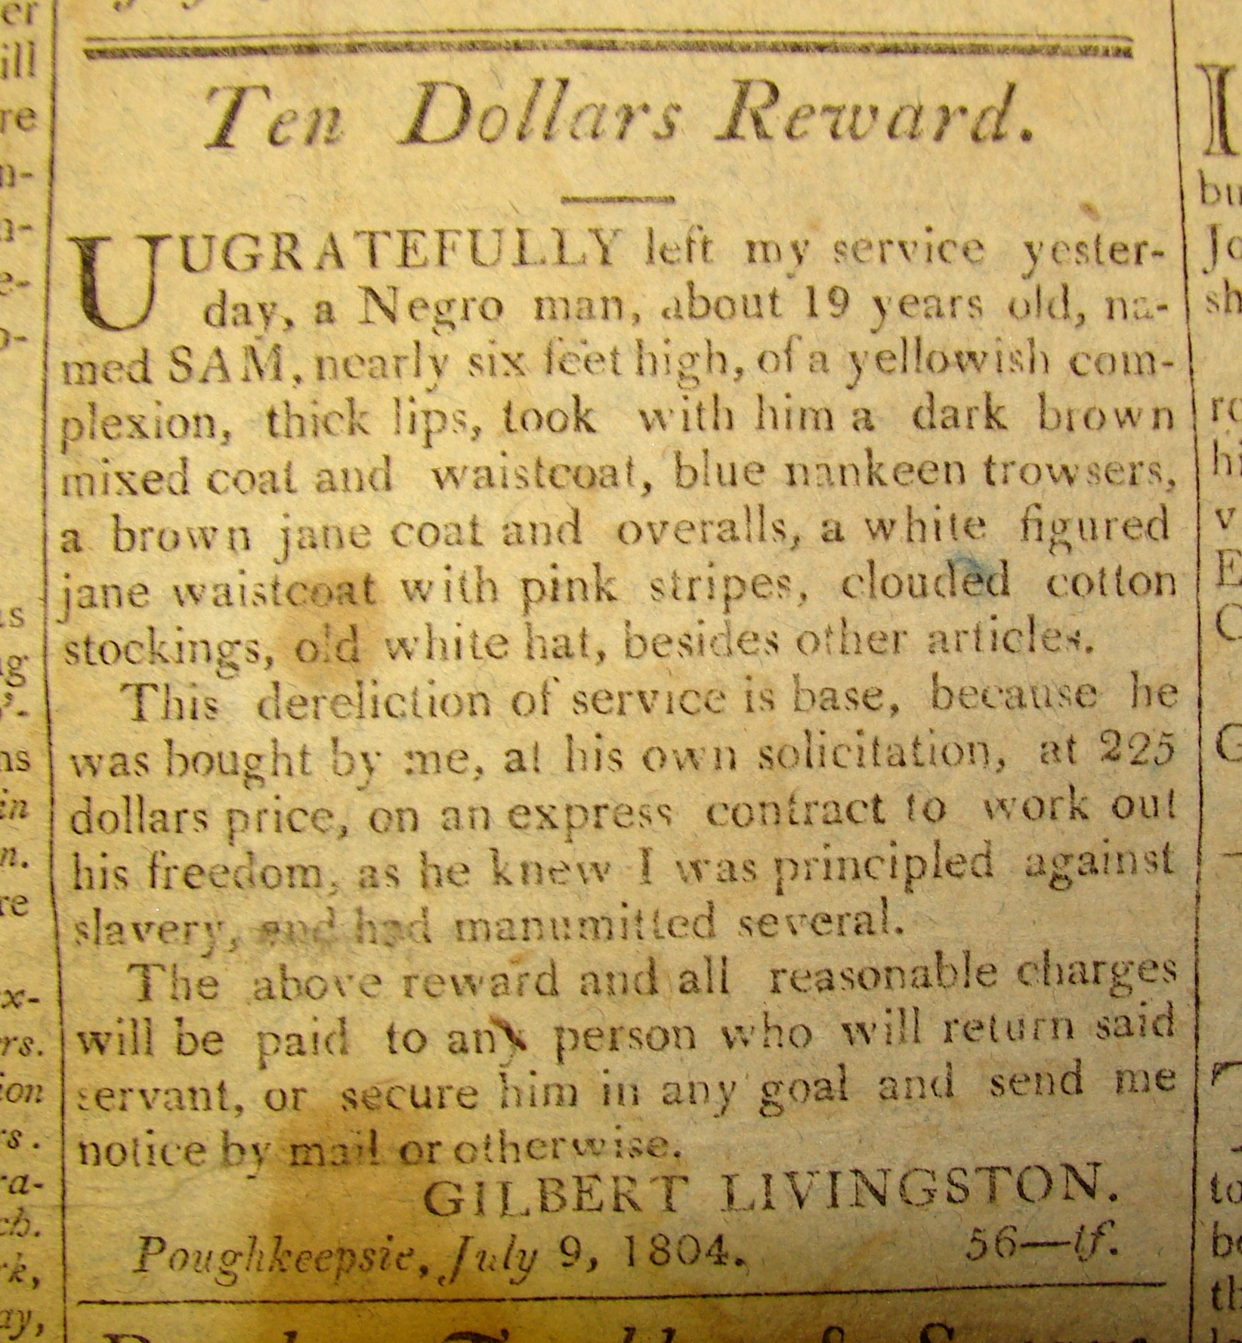

Ten Dollars Reward.
UNGRATEFULLY left my service yester-
day, a Negro man about 19 years old, na-
med SAM, nearly six feet high, of a yellowish com-
plexion thick lips, took with him a dark brown
mixed coat and waistcoat, blue nankeen trowsers,
a brown jane coat and overalls, a white figured
jane waistcoat with pink stripes, clouded cotton
stockings, ols white hat, besides other articles.
This dereliction of service is base, because he
was bought by me, at his own solicitation, at 225
dollars price, on an express contract to work out
his freedom, as he knew I was principled against
slavery, and had manumitted several.
The above reward and all reasonable charges
will be paid to any person who will return said
servant, or secure him in any gaol and send me
notice by mail or otherwise.
GILBERT LIVINGSTON
Poughkeepsie, July 9, 1804.

