PORT-ROYAL OF NEW-CASTLE
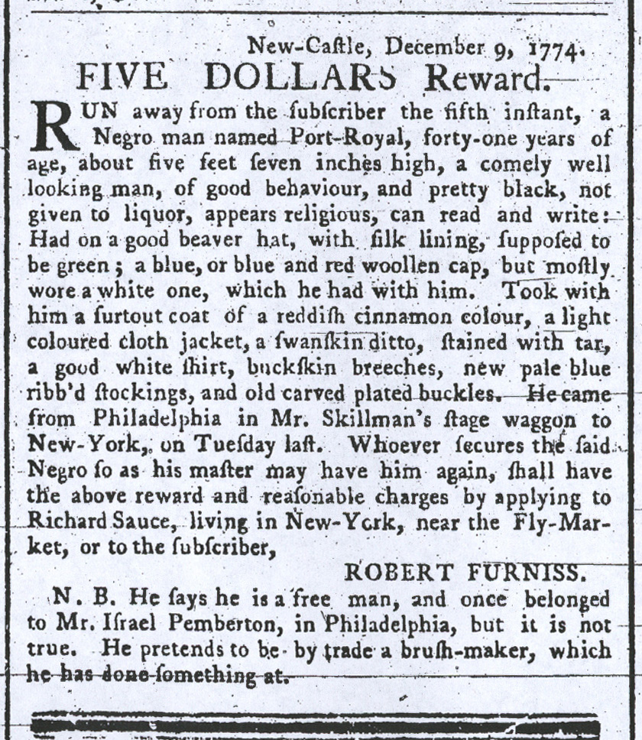

New-Castle, December 9, 1774.
FIVE DOLLARS Reward.
RUN away from the subscriber the fifth instant, a
Negro man named Port-Royal, forty-one years of
age, about five feet seven inches high, a comely well
looking man, of good behavior, and pretty black, not
given to liquor, appears religious, can read and write:
Had on a good beaver hat, with silk lining, supposed to
be green; a blue or blue and red linen cap, but mostly
wore a white one, which he had with him. Took with
him a surtout coat of a reddish cinnamon colour, a light
coloured cloth jacket, a swanskin ditto, stained with tar,
a good white shirt, buckskin breeches, new pale blue
ribb’d stockings, and old carved plated buckles. He came
from Philadelphia in Mr. Skillman’s stage wagon to
New-York, on Tuesday last. Whoever secures the said
Negro so as his master may have him again, shall have
the above reward and reasonable charges by applying to
Richard Sauce, living in New York, near the Fly-Mar-
ket, or to the subscriber,
ROBERT FURNISS.
N. B. He says he is a free man, and once belonged
to Mr. Israel Pemberton, in Philadelphia, but it is not
true. He pretends to be by trade a brush-maker, which
he has done something at.

