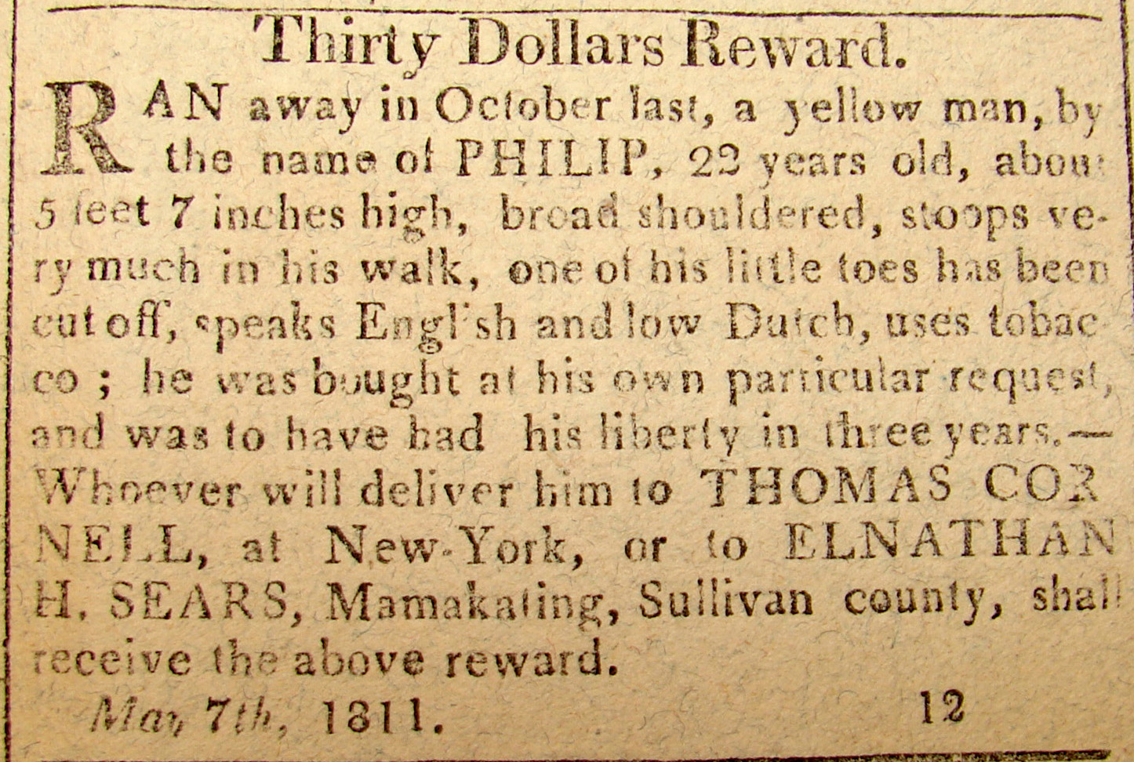
PHILIP OF SULIVAN COUNTY
Thirty Dollars Reward.
RAN away in October last, a yellow man, by
the name of PHILIP, 22 years old, about
5 feet 7 inches high, broad shouldered, stoops ve-
ry much in his walk, one of his little toes has been
cut off, speaks English and low Dutch, uses tobac
co: he was bought as his own particular request,
and was to have had his liberty in three years.-
Whoever will deliver him to THOMAS COR
NELL, at New York, or to ELNATHAN
H. SEARS, at Mamakating, Sullivan county, shall
receive the above reward.
May 7th, 1811.

