PETER OF GOSHEN
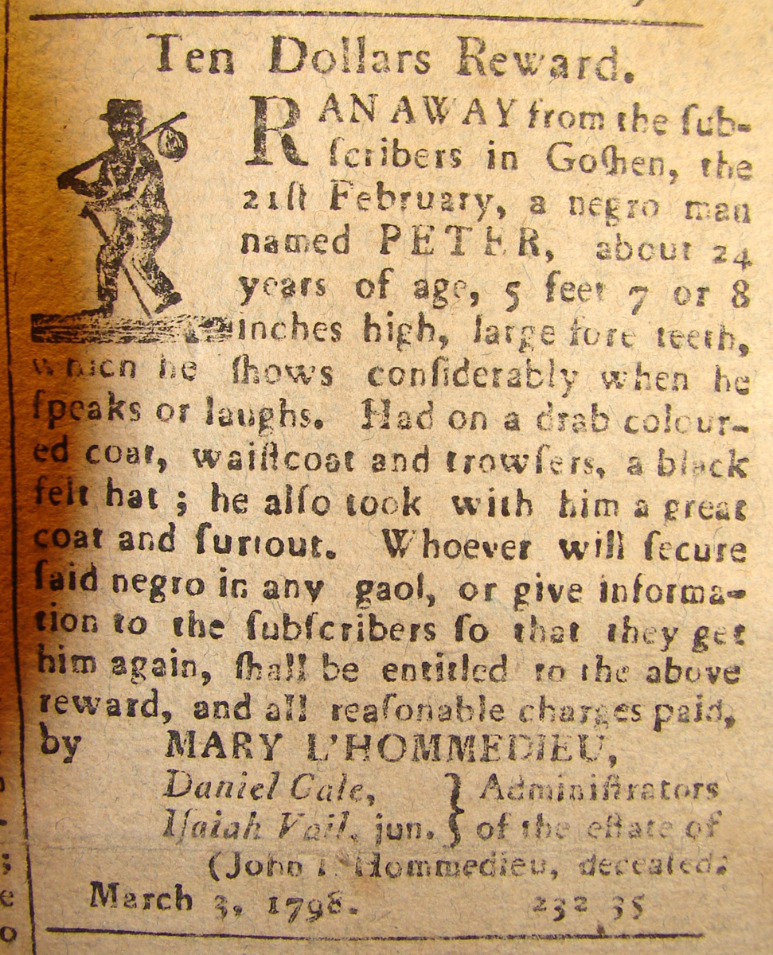

Ten Dollars Reward.
RAN AWAY fro the sub-
scriber in Goshen, the
21sr February, a negro man
named PETER, about 24
years of age, 5 feet 7 or 8
inches high, large fore teeth
which he shows considerably when he
speaks or laughs. Had on a drab colour-
ed coat, waistcoat and trousers, a black
felt hat; he also took with him a great
coat and [sunout], Whoever will secure
said negro in any gaol, or give informa-
tion to the subscribers so that they get
him again, shall be entitled to the above
reward, and all reasonable charges paid,
by MARY L’HOMMEDIED
Daniel Cole, Administrators Isiah Vail, jun, of the estate of
John L’Hommedieu, deceased
March 3, 1798.

