PETER of COLDENHAM
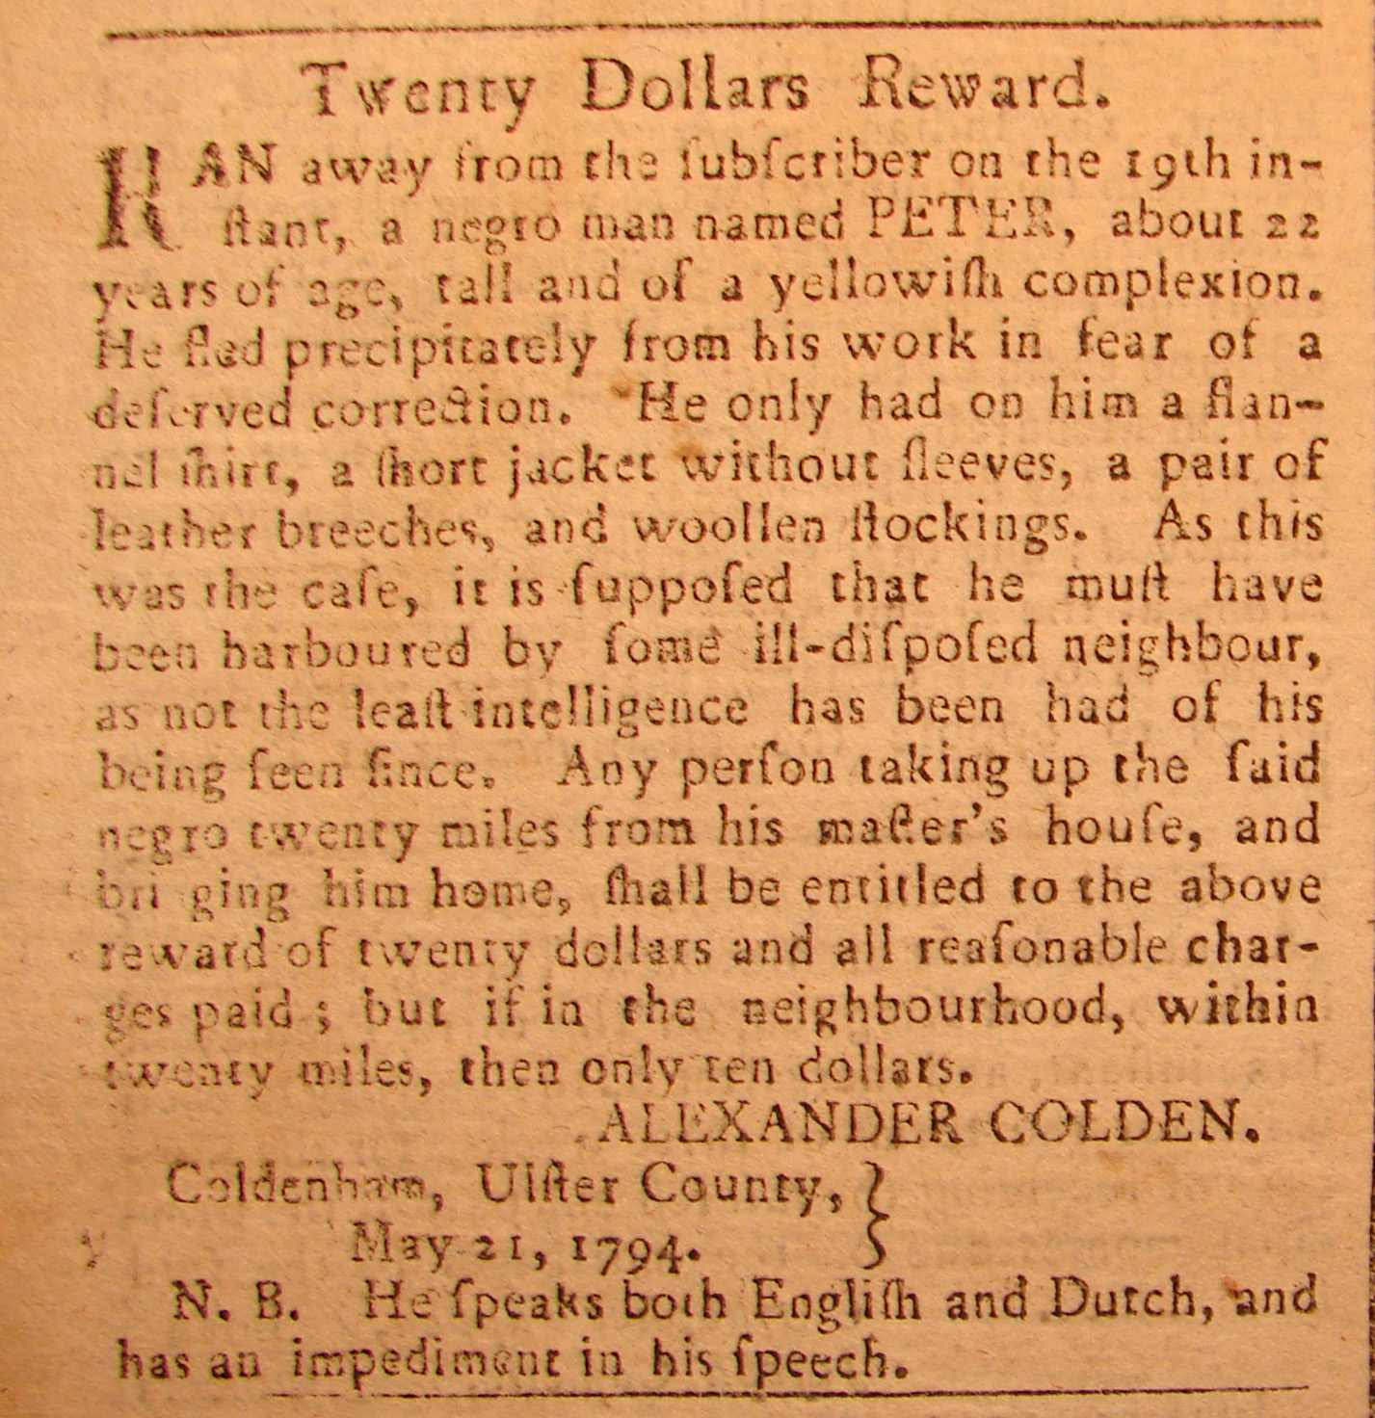
Twenty Dollars Reward.
Ran away from the subscriber on the 19th in-
stant, a negro man named PETER, about 22
years of age, tall and of a yellowish complexion.
He fled precipitately from his work in fear of a
deserved correction. He only had on him a flan-
nel shirt, a short jacket without sleeves, a pair of
leather breeches, and woolen stockings. As this
was the case, it is supposed that he must have
been harboured by some ill-disposed neighbour,
as not the least intelligence has been had of his
being seen since. Any persons taking up the said
negro twenty miles from his master’s house, and
bringing him home, shall be entitled to the above
reward of twenty dollars and all reasonable
charges paid; but if in the neighbourhood , within
twenty miles, then only ten dollars.
ALEXANDER COLDEN
May 21, 1794.
N. B. He speaks both English and Dutch, and
has an impediment in his speech.

