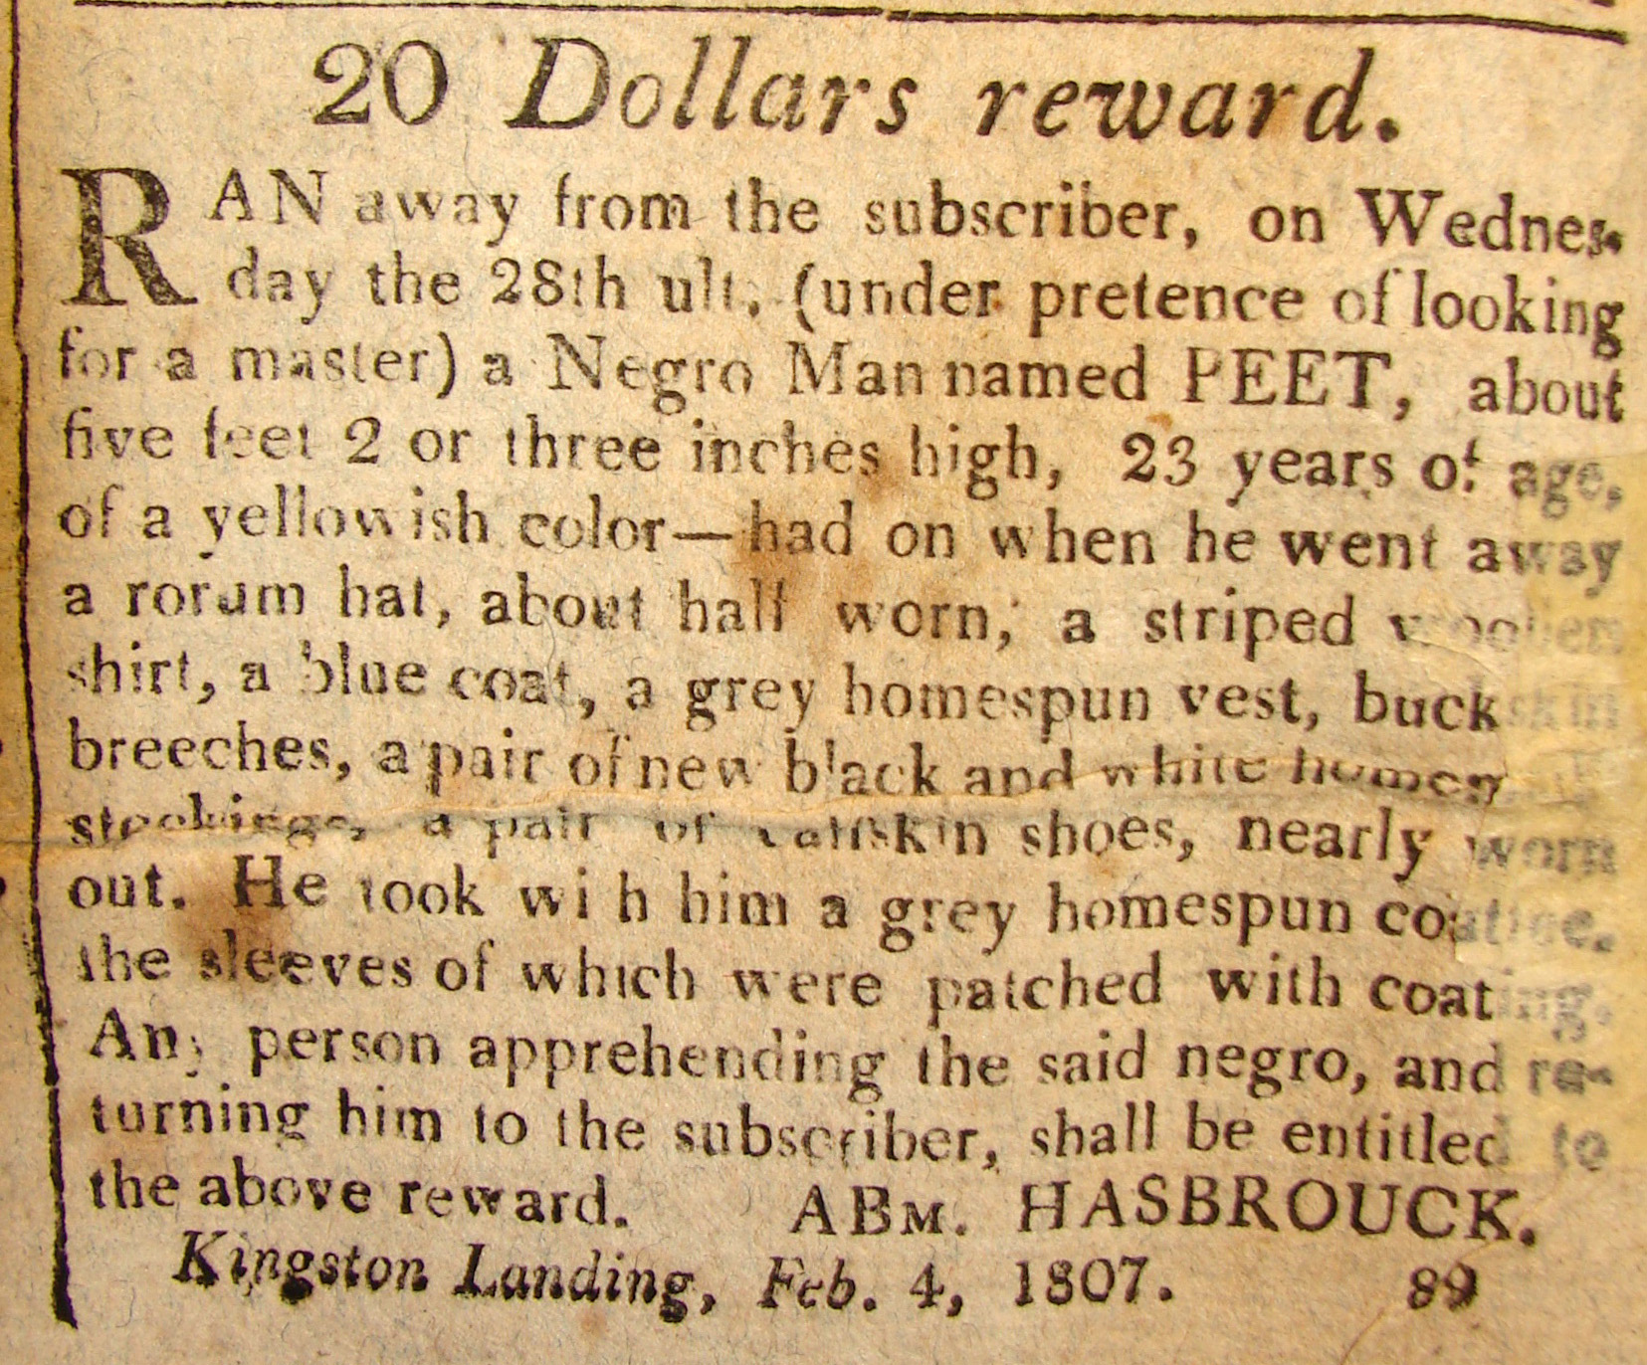
PEET OF Kingston
- Dollars reward.
RAN away from the subscriber, on Wednes-
day the 28th ult. (under pretence of looking
for a master) a Negro Man named PEET, about
five feet 2 or 3 inches high. 23 years of age,
of a yellowish color—had on when he went away
a rorum hat, about half worn, a striped woollier
shirt, a blue coat, a grey homespun vest, buck
breeches, a pair of new black and white home[spun]
stockings, a pair of calfskin shoes, nearly worn
out. He took with him a grey homespun coat
and sleeves of which were patches with coating.
any person apprehending the said negro and re-
turning him to the subscriber, shall be entitled to
the above reward. ABM. HASBROUCK.
Kingston Landing, Feb. 4, 1807.

