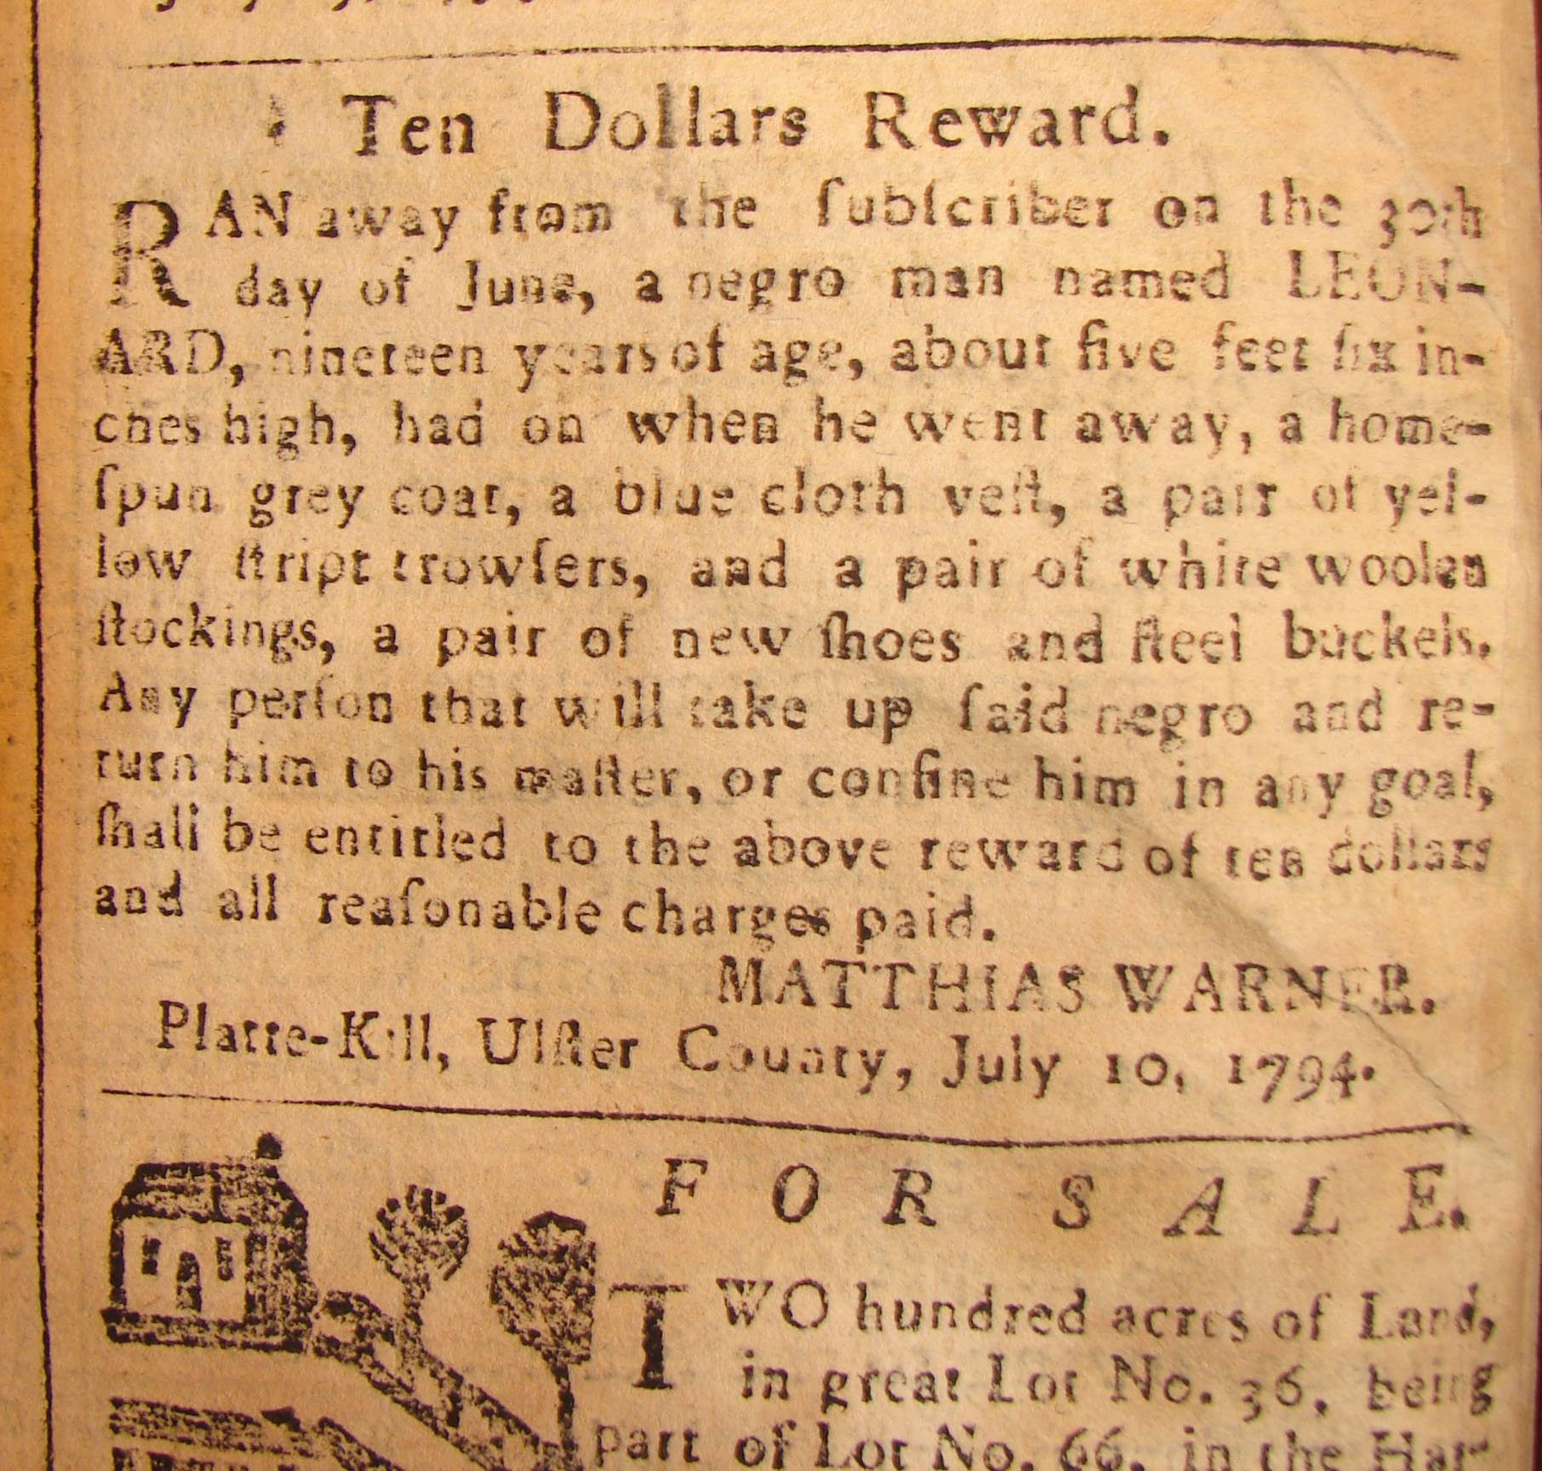
LEONARD of PLATTEKILL

Ten Dollars Reward.
RAN away from the subscriber on the 30th
day of June, a negro man named LEON-
ARD nineteen years of age, about five feet six in-
ches high, had on when he went away, a home-
spun grey coat, a blue cloth veil, a pair of yel-
low stript [sic] trowsers [sic], and a pair of white woolen
stockings, a pair of new shoes and steel buckels [sic],
Any person that will take up said negro, and re-
turn him to his master, or confine him in any goal,
shall be entitled to the above reward of ten dollars
and all reasonable charges paid.
Mathias Warner
Platte-kill, Ulster County, July 10, 1794.

