JAMES OF WOODBRIDGE
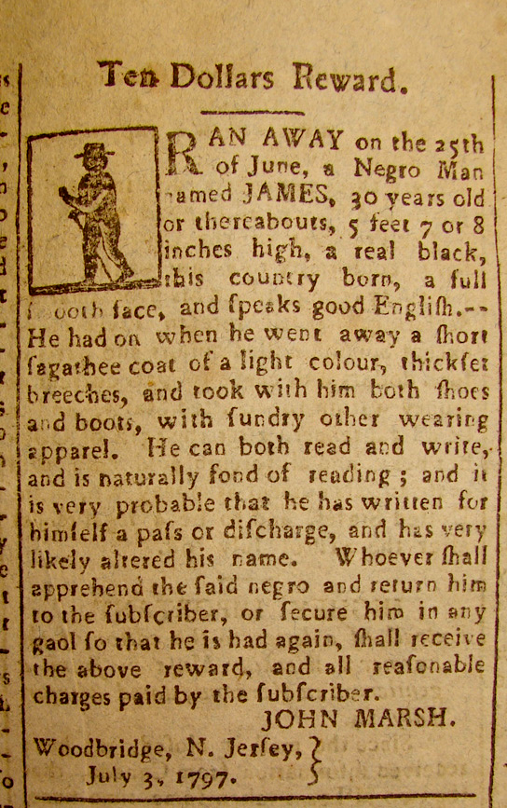
Ten Dollars Reward.
RAN AWAY on the 25th
of June, a Negro Man
named JAMES, 30 years old
or thereabouts, 5 feet 7 or 8
inches high, a real black
this country born, a full
smooth face, and speaks good English. - -
He had on when he went away a short
sagathee coat of a light colour, thickfet
breeches, and took with him both shoes
and boots, with sundry other wearing
apparel. He can both read and write,
and is naturally fond of reading; and it
is very probably that he has written for
himself a pass or discharge, and has very
likely altered his name. Whoever shall
apprehend the said negro and return him
to the subscriber, or secure him in any
goal so that he is had a gain, shall receive
the above reward, and all reasonable
charges paid by the subscriber.
JOHN MARSH.
Woodbridge, N. Jersey.
July 3, 1797.

