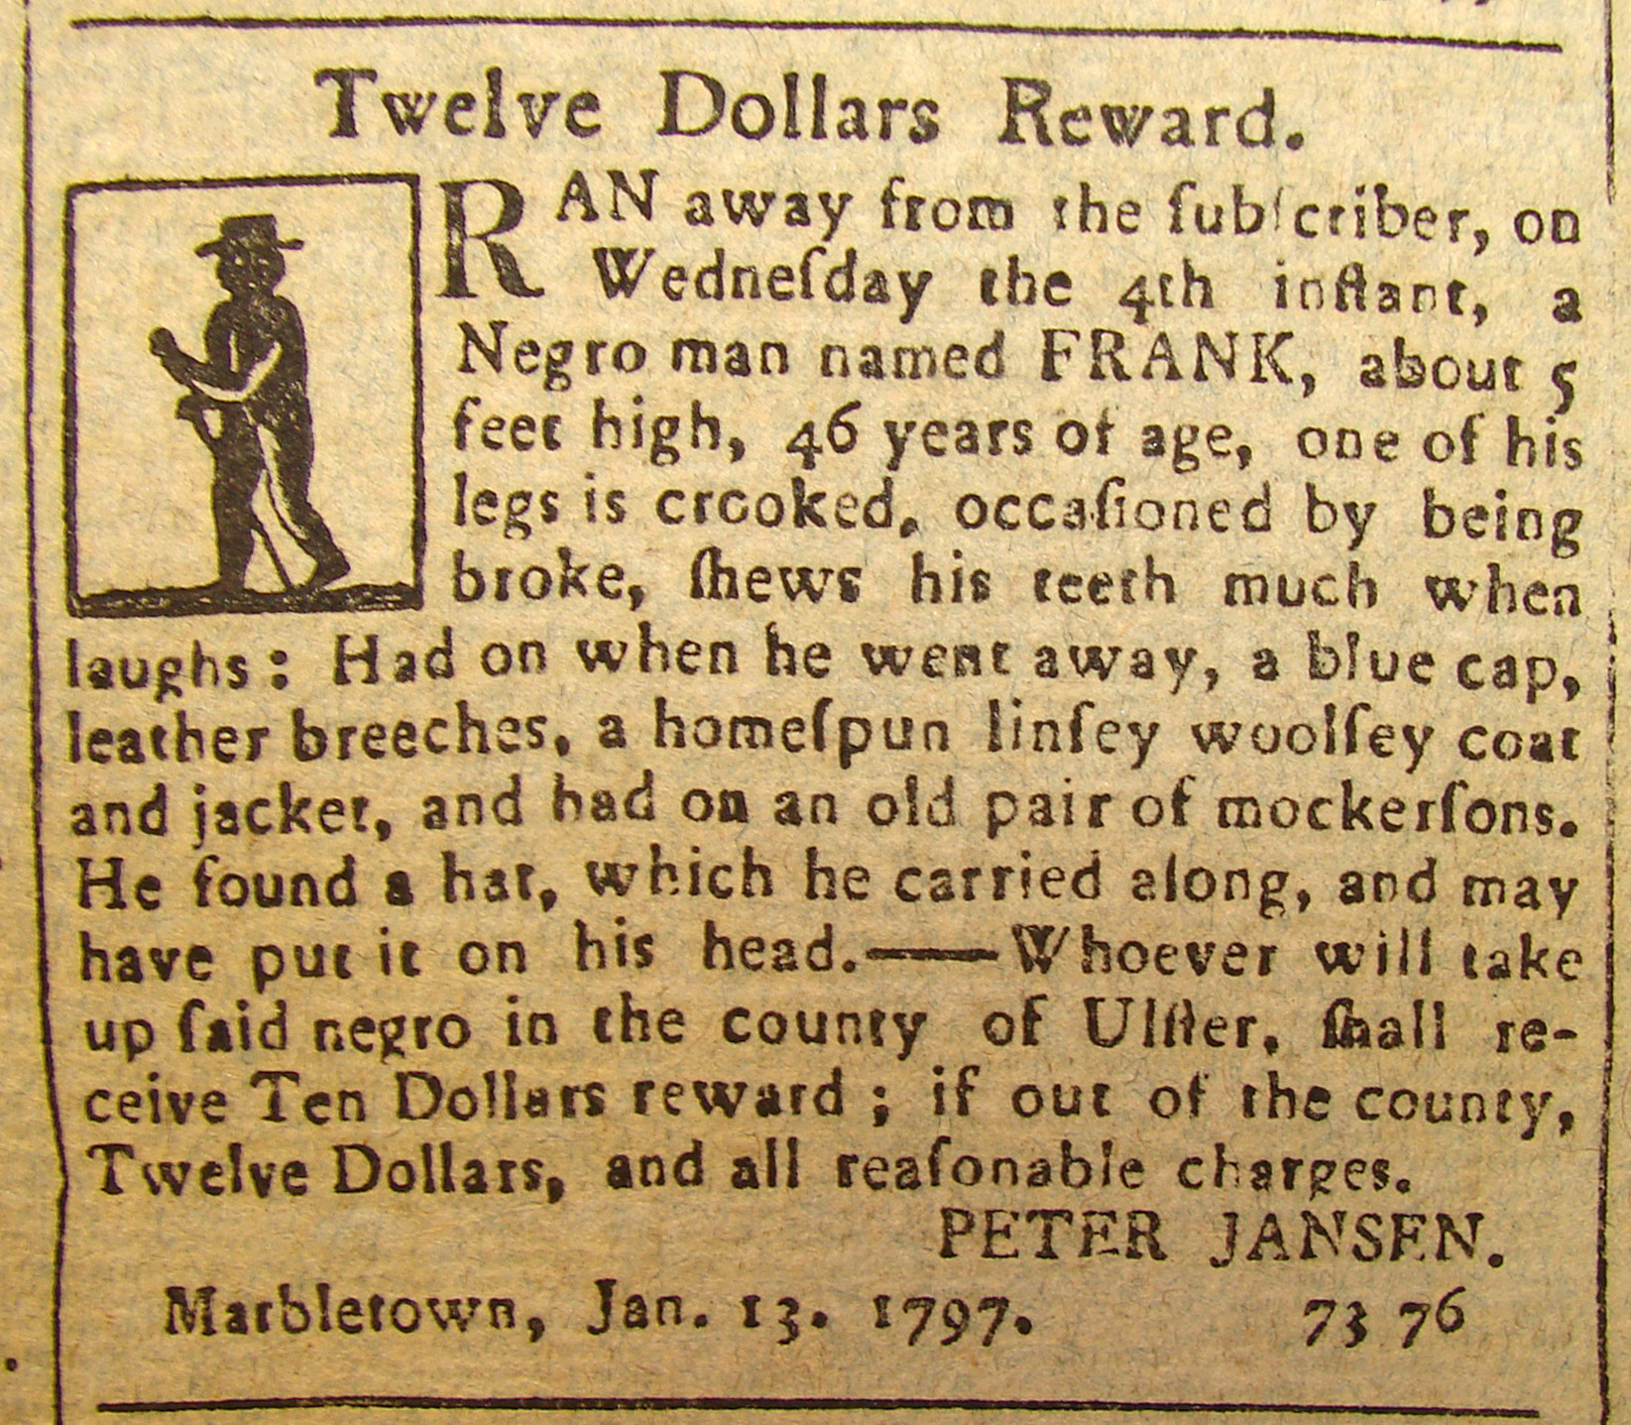
FRANK OF MARBLETOWN

Twelve Dollars Reward
Ran away from the subscriber, on
Wednesday the 4th inst., a
Negro man named FRANK, about 5
feet high, 46 years of age, one of his
legs is crooked, occasioned by being
broke, shews [sic] his teeth much when
laughs, Had on when he went away, a blue cap,
leather breeches, a homespun linsey woolsey coat
and jacket, and had on an old pair mockersons [sic].
He found a hat, which he carried along, and may
have put it on his head. ------Whoever will take
up said negro in the county of Ulster, shall re-
ceive Ten Dollars reward: if out of the county,
Twelve Dollars, and all reasonable charges.
PETER JANSEN
Marbletown, Jan.13, 1797.

