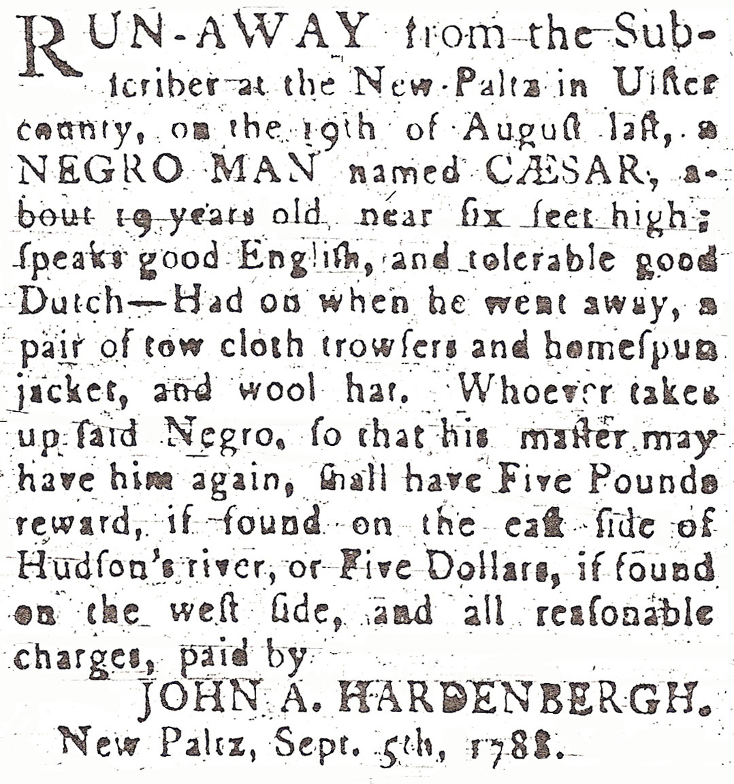
CAESAR OF NEW PALTZ

RUN-AWAY from the Sub-
scriber at the New Paltz in Ulster
county, on the 19th of August last, a
NEGRO MAN named CAESAR, a-
bout 19 years old, near six feet high;
speaks good English, and tolerable good
Dutch—Had on when he went away, a
pair of tow cloth trowsers and homespun
jacket, and wool hat. Whoever takes
up said Negro, so that his master may
have him again, shall have Five Pounds
reward, if found on the eastside of
Hudson river, or Five Dollars, if found
on the west side, and all reasonable
charges, paid by
JOHN A. HARDENBERGH.
New Paltz, Sept. 5th, 1788.

