BEN OF DUTCHESS OR NEW PALTZ
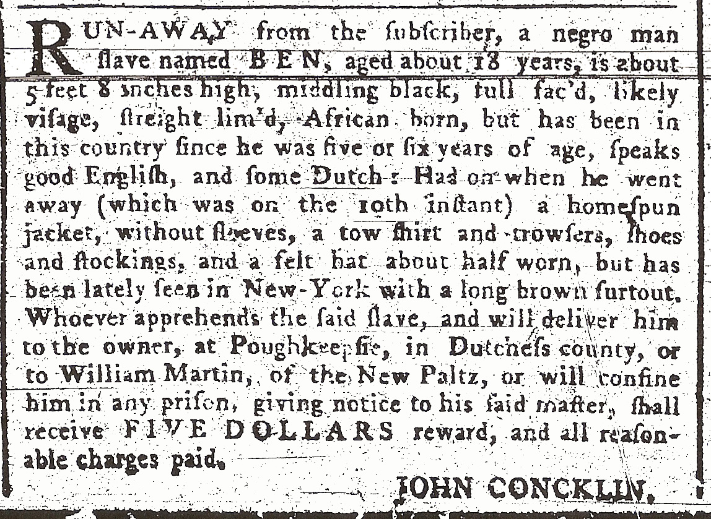

RUN-AWAY from the subscriber, a negro man
slave named BEN, aged about 18 years, is about
5 feet 8 inches high, middling black, full fac’d, likely
visage, straight lim’d, African born, but has been in
this country since he was five or six years of age, speaks
good English, and some Dutch: Had on when he went
away (which was on the tenth instant) a homespun
jacket, without sleeves, a tow shirt and trowsers, shoes
and stockings, and a felt hat about half worn, but has
been lately seen in New York with a long brown surtout.
Whoever apprehends the said slave, and will deliver hime
to the owner at Poughkeepsie, in Dutchess county, or
to William Martin, of the New Paltz, or will confine
him in any prison, giving notice to his said master, shall
receive FIVE DOLLARS reward, and all reason-
able charges paid.
JOHN CONKLIN.

