ADDONIJAH OF DUTCHESS COUNTY
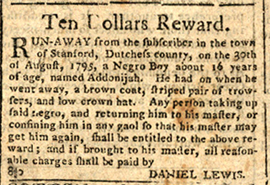
.

Ten Dollars Reward.
RUN-AWAY from the subscriber in the town
of Stanford, Dutchess county, on the 30th
of august, 1795, a Negro Boy, about 16 years
of age named Addonijah. He had on when he
went away, a brown coat, striped pair of trow-
sers, and low crowned hat. Any person taking up
said negro, and returning him to his master, or
confining him in any gaol so that his master may
get him again, shall be entitled to the above re-
ward: and if brought to his master, all reason-
able charges shall be paid by
DANIEL LEWIS.

