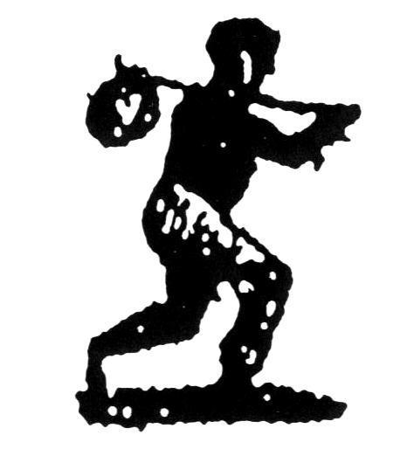
Run-Away Activity Sheet

Use all of the documents in your packet to fill in the following chart:

Date of Notice | Age of Slave | Month of Escape | Town Escaped From | Languages Spoken | Types of Skills

- Using the Glossary of Terms, choose four words from the Run-away Slave Notices that are unfamiliar. Define them.
  - __________________________________________________________________________________________________________________________________________
    - __________________________________________________________________________________________________________________________________________
    - __________________________________________________________________________________________________________________________________________
    - __________________________________________________________________________________________________________________________________________

- What is the date range of the notices?____________________________________ _____________________________________________________________________

- What is the average age of the slaves mentioned in the notices? _____________

- Why do you think slaves choose the months they did to flee?_______________ ____________________________________________________________________________________________________________________________________________________________________________________________________________________________________________________________________________________

5. How would the skills slaves possessed help them in their flight to freedom? ____________________________________________________________________________________________________________________________________________________________________________________________________________________________________________________________________________________

- Describe some of the clothing slaves wore when they escaped. Why do you think the writers of these ads used such detailed descriptions of these clothes?__________________________________________________________________________________________________________________________________________________________________________________________________________________________________________________________________________________________________________________________________________________
_____________________________________________________________________

- What can you tell about how some slaveholders treated their slaves? How do you know this?_______________________________________________________ _________________________________________________________________________________________________________________________________________________________________________________________________________________________________________________________________________________________________________________________________________________________

- What consequences might a captured fugitive slave face ? _______________________________________________________________________________________________________________________________________________________________________________________________________________
__________________________________________________________________________________________________________________________________________

