Glossary of Terms

Bay: A compartment in a barn, used fore storing hay or grain.

Britches or Breeches: Short trousers, especially fastened below the knee. Breeches were originally made of leather, but were made of various materials.

Buckskin: Leather made from a buck’s skin, could also refer to a thick smooth cotton or woolen cloth.

Coating: A cloth used for making coats.

Drab coloured: A dull brownish yellow or dull gray color.

Felt: A fabric made of wool and hair.

Fife: A small high-pitched flute without keys, often used in military and marching bands.

Fustian: A coarse sturdy cloth of a cotton-linen blend; any durable fabric with a raised nap made mainly from cotton, for example, corduroy or moleskin.

Gaol: is an early Modern English spelling for jail, with the same pronunciation and meaning of a place of legal detention.

Grogram: A rough fabric of silk and wool with a diagonal weave.

High Dutch: An eighteenth century term for German.

Homespun: Spun or woven in the home; a plain coarse woolen cloth made of homespun yarn.

Instant (inst.): The current calendar month.

Inventory: a detailed list of things in one’s view or possession; especially, a regular survey of all goods and materials in stock.

Linsey Woolsey: A coarse fabric of cotton or linen woven with wool.

Low Dutch: used to signify those persons of Netherlandish descent.

Manchester velvet: A fine cotton used in making dresses.

Nanekeen: A sturdy yellow or buff cotton cloth.

N.B. The abbreviation for nota bene, which means to pay particular attention to what follows.

Rorum hat: Wool or felt, with a facing of long beaver fur felted in.

Sagathee: a durable woolen stuff.

Snuff coloured: Brown or brownish. It can be described as the color of cinnamon, which is a yellowish brown.

Sundry: various, several, miscellaneous.

Surtout (sartout): A man’s greatcoat or overcoat.

Swankskin: A fine type of flannel, thick and warm.

Thickset: A material possessing a close grained nap; Short, heavy, and solidly built.

Tow cloth: A coarse heavy linen; the short fibers of flax or hemp, which are separated from the longer ones by heckling.

Trousers: An outer garment for covering the body from the waist to the ankles, divided into sections to fit each leg separately, worn especially by men and boys.

Vendue: A public sale or auction.

Visage: The face or facial expression of a person.

Waistcoat: An under jacket or a vest.

Wench: A young woman or girl; especially a peasant girl; a servant girl.

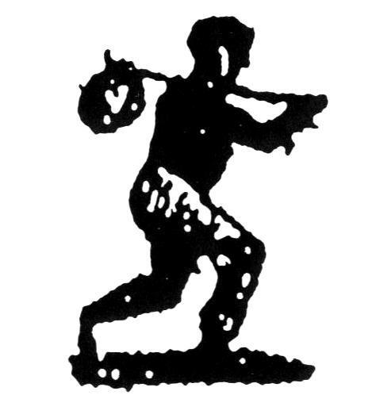
Worsted: A woolen cloth first made at Worestead England.

