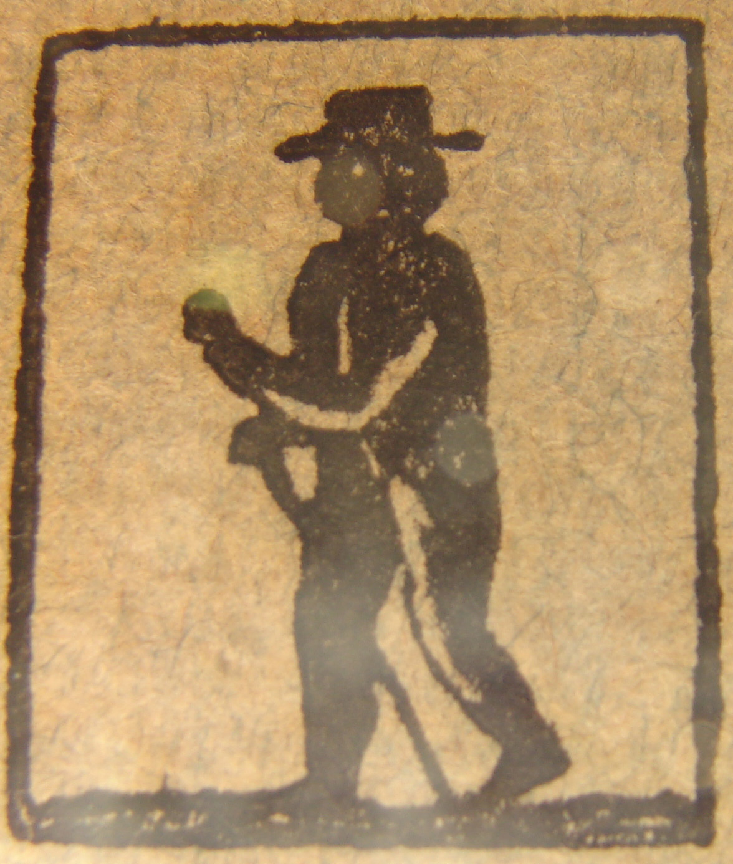
RUN-AWAY

Objectives - Students will :
- compile, analyze and interpret information from 18th and 19th
century runaway slave ads,
- make assumptions as to what life was like for enslaved Africans
living in New York during the 18th and early 19th century.

learning standards – See chart

Materials
- Runaway slave advertisements from 18th and early 19th
Taken from the Rising Sun Newspaper, August 17, 1797.
- Glossary of Terms Sheet
- Conversion Chart
- An act to Prevent the Running Away of Slaves Sheet
- Student Activity Sheet
- Magnifying glasses if available

Background information
“First and foremost, runaway notices are evidence of slave resistance. As Peter Wood has remarked ‘no single act of self-assertion was more significant among slaves or more disconcerting among whites than that of running away.’ Above all, flight was the most effective individual means of struggle against slavery; through escape, slaves were active agents who undermined the system of subjugation.”
-“Pretend to be Free” by Graham Russel Hodges’

Although, slave masters of the 18th century boasted of how well treated and content their slaves were, life for the enslaved African living in the North was harsh, tedious and unrewarding. The hope of attaining freedom inspired hundreds of slaves to risk the perils of running away and live a fugitive life. Living on the run was dangerous in itself, but if caught, a fugitive slave could expect punishments ranging from flogging, amputation of limbs or death. In May of the year 1775 an Act was passed to prevent slaves from running away to Canada. If convicted of trying to escape to Canada the penalty was “he, she shall suffer the Pains of Death ”. The owner of said slave would be compensated for their financial loss “not to exceed the sum of five pounds”.

Many fugitive slaves found refuge in the woods of upstate New York. The woods not only provided cover and protection but a chance to seek Native Americans inhabiting the region. Many found shelter and safety with Native Americans and were welcomed into their tribes. Large rewards and treaty offerings for the return of runaways did not dissuade Native nations from harboring slaves.

Slave masters in some rural areas used especially harsh methods to deter their slaves from running away. According to Charles H. Cochrane’s, The History of the Town of Marlborough, Ulster County, New York: From the First Settlement in 1712 by Captain Wm. Bond to 1887:

“Those that could afford it kept slaves, and each owner put a mark upon his black servants, and registered the same with the town clerk, in order that runaways might be more easily traced. For instance the mark of Mathew Wygant was ‘a square notch of ha’penny on the upper sie of the left ear’.”

Runaway slave notices are some of the earliest clues we have as to the interior lives of slaves living in New York during the 18th and early 19th century. These notices often revealed the ethnicity, work culture, languages spoken and appearances of enslaved Africans. Often a slave’s religious beliefs as well as personal habits were noted.

The greatest amount of information found in run-away notices is the outerwear worn by slaves. The clothing stated in these notices reflected the deprived existences they led. Styles of clothing, including the color and material the clothing was made of, hairstyles and types of headwear are recalled in great detail by slave masters. This was crucial information since most fugitive slaves ran away with only one set of clothes.

Some of the comments made by masters in these ads reflect the mistreatment of their slaves. Alexander Colden, grandson of Cadawaller Colden, Governor of NY, mentions that his slave Peter “fled precipitately from his work in fear of a deserved correction.” One can only surmise what the term “correction” might entail.

Through run-away slave notices, we are able to form individual and group portraits of 18th and early 19th century African American slaves. We find restless, tired young men and women fed up with the psychological and physical maltreatment they were forced to endure as enslaved people.



teaching sequence
- Class Discussion
  - The class begins using the word resistance written in a word web.
  - Students can work in groups or pairs to complete the word web in their seats.

WORD WEB

Definition – refusal to accept or comply with something; opposition to somebody or something

Word - Resistance
Synonym - fight
Antonym – surrender
Content sentence –
Part of speech – noun
Related Topic -

  - Explain to students how enslaved Africans resisted the system of slavery. One example is by running away. Discuss the dangers escaped slaves faced in their attempt to run away. Read excerpts from the 1775 Act to Prevent the Running Away of Slaves Law. Explain how easy it would be for any slaves to be convicted of heading north.
- Interpreting information from newspaper notices
  - Divide the class into groups of four. Use cooperative learning strategies to assign roles to members in each group.
  - Distribute four to six Run-Away Slave Notices, a Glossary of Terms Sheet, Money Conversion Chart, and a blank Activity Sheet to each group.
  - Explain that the documents the students are using are copies of real newspaper clippings. Have them look at one document. Ask students to look for any letter that appears strange to them. They will notice the letter s often appears as an f. Until the mid-19th century, the letter s was often written to appear similar to the letter f.
  - Instruct students to read the Money Conversion Chart to help understand reward amounts.
  - Instruct the group to go over each document and then fill in the Activity Sheet.
- Class Discussion
  - When students have completed their sheet (approx. 30 minutes), bring the class together and have students share their findings. (One student from each group was previously selected as the spokesperson.)
  - Compile all the information into one large chart.
  - Have students answer the following question – How do these ads help us learn about the history of slavery? Why are they so valuable?

